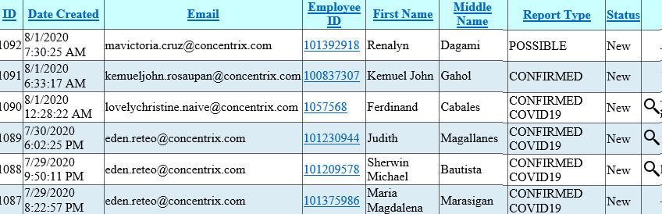

Background de header <tr style="background-color:#CCFFFF;">

Background de alternative row <tr style="background-color:#DCECF4;">

<td>[mavictoria.cruz@concentrix.com</td](mailto:mavictoria.cruz@concentrix.com%3c/td)>

<td><a href="javascript:__doPostBack(&#39;dg&#39;,&#39;Detail$0&#39;)">101392918</a></td>

**SIMPLER**

<td>

<a href="#" onclick="OpenWin(‘1092’);">mavictoria.cruz@concentrix.com </a>

</td>

<td><input type="image" title="View Attachments" src="Look.ico" alt="View" onclick="javascript:__doPostBack(&#39;dg&#39;,&#39;ViewDoc$2&#39;);return false;" />

**SIMPLER**

<td>

<input type=’image’ onclick=ShowFiles(‘1092’); return false; />

</td>

**TABLE , HEAD – SORT**

<table cellspacing="0" rules="all" border="1" id="dg" style="border-collapse:collapse;">

<tr style="background-color:#CCFFFF;">

<th scope="col"><a href="javascript:__doPostBack(&#39;dg&#39;,&#39;Sort$ID&#39;)">ID</a></th>

<th scope="col"><a href="javascript:__doPostBack(&#39;dg&#39;,&#39;Sort$DateCreated&#39;)">Date Created</a></th>

<th scope="col"><a href="javascript:__doPostBack(&#39;dg&#39;,&#39;Sort$Email&#39;)">Email</a></th>

<th scope="col"><a href="javascript:__doPostBack(&#39;dg&#39;,&#39;Sort$EmpID&#39;)">Employee ID</a></th>

<th scope="col"><a href="javascript:__doPostBack(&#39;dg&#39;,&#39;Sort$FirstName&#39;)">First Name</a></th>

<th scope="col"><a href="javascript:__doPostBack(&#39;dg&#39;,&#39;Sort$MiddleName&#39;)">Middle Name</a></th>

<th scope="col"><a href="javascript:__doPostBack(&#39;dg&#39;,&#39;Sort$Status&#39;)">Status</a></th>

<th scope="col">&nbsp;</th>

</tr>

<tr>

<td>1092</td><td>8/1/2020 7:30:25 AM</td><td>[mavictoria.cruz@concentrix.com</td](mailto:mavictoria.cruz@concentrix.com%3c/td)>

<td><a href="javascript:__doPostBack(&#39;dg&#39;,&#39;Detail$0&#39;)">101392918</a></td>

<td>Renalyn</td>

<td>Dagami</td>

<td>POSSIBLE</td><td>New</td><td></td>

</tr>

<tr>

<td>1090</td><td>8/1/2020 12:28:22 AM</td><td>[lovelychristine.naive@concentrix.com</td><td](mailto:lovelychristine.naive@concentrix.com%3c/td%3e%3ctd)>

<a href="javascript:__doPostBack(&#39;dg&#39;,&#39;Detail$2&#39;)">1057568</a></td>

<td>Ferdinand</td><td>Cabales</td><td>Gutierrez II</td>

<td>CONFIRMED COVID19</td>

<td><input type="image" title="View Attachments" src="Look.ico" alt="View" onclick="javascript:__doPostBack(&#39;dg&#39;,&#39;ViewDoc$2&#39;);return false;" />

</td>

</tr>

<tr style="background-color:#DCECF4;">

<td>1089</td><td>7/30/2020 6:02:25 PM</td><td>eden.reteo@concentrix.com</td><td><a href="javascript:__doPostBack(&#39;dg&#39;,&#39;Detail$3&#39;)">101230944</a></td><td>Judith</td><td>Magallanes</td><td>Gamez</td><td>PHL Mandaluyong City - Shaw 2</td><td>Globetelecom Pgm</td><td>CONFIRMED COVID19</td><td>New</td><td><input type="image" title="View Attachments" src="Look.ico" alt="View" onclick="javascript:__doPostBack(&#39;dg&#39;,&#39;ViewDoc$3&#39;);return false;" /></td>

</tr><tr>